Class X Maths
- Euclid’s division lemma : Given positive integers a and b ,there exists unique integers q and r satisfying a= b q + r , 0 ≤ r <b.
- Fundamental theorem of Arithmetic : Every composite number can be expressed as a product of primes.
- In rational number $\frac{p}{q}$ ,q is always in form of 2^{n}5^{m} ( for terminating decimal representation).
- HCF (a,b) x LCM (a,b) = a x b. ******************************************************************************
- Zeroes of a polynomial : k is zero of polynomial P(x) if P(k) = 0.
- Sum of zeroes α+β = -$\frac{b}{a} ,$product of zeroes α x β = $\frac{c}{a}$ for polynomial ax²+ bx + c= x² – (α +β)x + αβ
- For cubic polynomial , ax³ + bx²+cx + d α + β +γ =- -$\frac{b}{a}$, αβ+βγ+γα = $\frac{c}{a}$ , αβγ = $-\frac{d}{a}$ *****************************************************************************
- For a₁ x + b₁y +c₁=0 and For a₂ x + b₂y +c₂ =0 , unique solution : $\frac{a_{1}}{a_{2}} ≠\frac{b_{1}}{b_{2}}$ graph : two intersecting lines no solution : $\frac{a_{1}}{a_{2}}=\frac{b_{1}}{b_{2}}≠\frac{c_{1}}{c_{2}}$ parallel lines infinite solution : $\frac{a_{1}}{a_{2}}=\frac{b_{1}}{b_{2}}=\frac{c_{1}}{c_{2}}$ coincident lines
- Elimination method to solve equations ******************************************************************************
- ax²+ bx + c = 0 root are real if D = b² – 4ac $≥$0 roots are equal if D = b² – 4ac = 0 , x = $\frac{-b ± \sqrt{D}}{2a}$ ******************************************************************************
- General term a_{n} = a + (n-1)d where a= first term , d = common difference S_{n} = $\frac{n}{2}\left[2a+\left(n-1\right)d\right]= \frac{n}{2} \left[a+l\right]$ A.P. : a , a+d , a+2d , ……….. ******************************************************************************
- Similarity rules of two triangles: (i) SSS (ii) SAS (iii) AA
- Theorem: (i) The ratio of the areas of two similar triangles is equal to the squares of the ratio of their corresponding sides.
- (ii) [BPT] If a line is drawn parallel to one side of a triangle ,it cuts other two sides in the same ratio.
- (iii) Pythagoras theorem : In right triangle , the square of the hypotenuse is equal to the sum of the squares of the other two sides. (iv) Converse of Pythagoras theorem : In a triangle , if square of one side is equal to the sum of the squares of the other two sides , then the angle opposite the first side is a right angle

Coordinate geometry
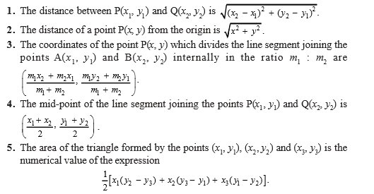

Trigonometric ratios
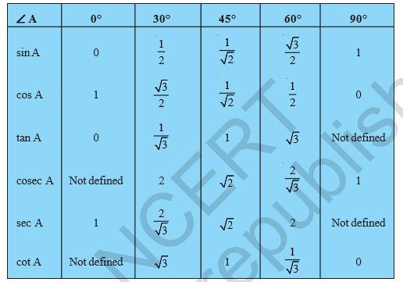
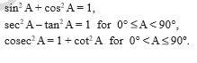
Circles
Theorems (i) The tangent at any point of a circle is perpendicular to the radius through the point of contact.
(ii) The length of tangents drawn from an external point to a circle are equal.
Area related to circle (i)Area of the sector = $\frac{θ}{360°}πr^{2}$ (ii) length of arc = $\frac{θ}{360°}2πr^{}$
(iii) Area of minor segment = $\frac{θ}{360°}πr^{2}- \frac{1}{2}r^{2} sinθ.$
Surface area and volume
 | CSA | TSA | Volume
Cube | 4a² | 6a² | a³
Cuboid | 2h(l+b) | 2(lb +bh + hl) | Lbh
Cylinder | 2$πrh$ | 2$πrh+2πr^{2}$ | $$πr^{2}h$$
Cone | $$πrl$$ | $$πrl+πr^{2}$$ | $$\frac{1}{3}πr^{2}h$$
Sphere | - | $$4πr^{2}$$ | $$\frac{4}{3}πr^{3}$$
Hemisphere | $$2πr^{2}$$ | $$3πr^{2}$$ | $$\frac{2}{3}πr^{3}$$

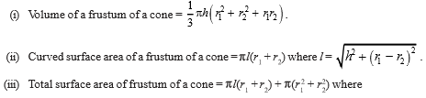

Statistics
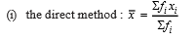
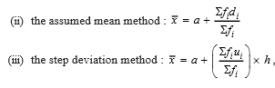
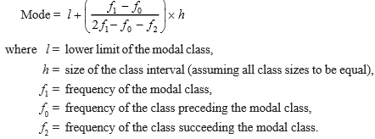

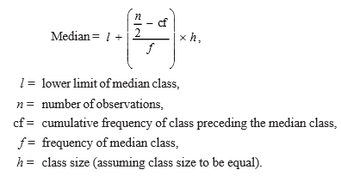
* Mode = 3Median – 2Mean
* more than ogive : plot points (lower limit , corresponding cumulative freuency)
* less than ogive : plot points (upper limit , corresponding cumulative freuency)
Probability
P(E) = $\frac{Number of outcomes favourable to E}{Number of all possible outcomes of experiment}$
Sum of probabilities of all events is always 1 in an experiment , 0$≤P(E)≤1$ , P(E) + P (Not E) = 1

