ICT Infrastructure
Vidyalaya is equipped with two computer labs having internet connection. In six class rooms and CMP room LCD projectors are installed to improvise the teaching learning process.
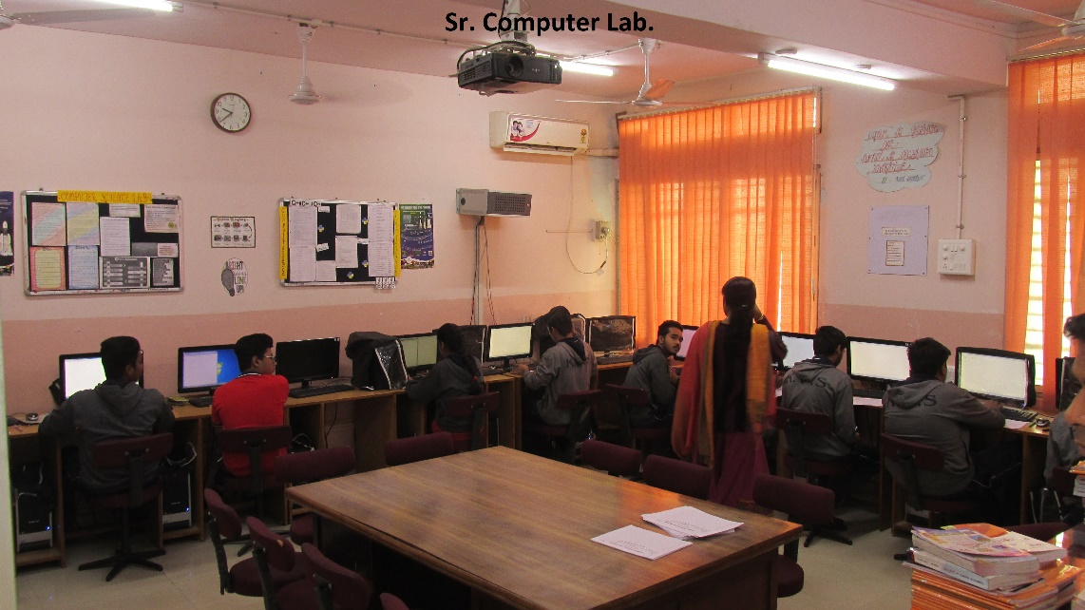

Digital Initiatives
- Shaala Darpan: An e-Governance platform for all Kendriya Vidyalayas in the country. Aims at improving the quality of learning, the efficiency of school administration, governance of schools & service delivery to key stakeholders.
- Online admission process: From the session 2017-18, admission in all the classes done online. Tons of paper and lakhs of man-hours saved. It also ensures transparency in the admission process.
- Online Transfer of employees: The entire process of transfer being done online since 2016-17.
- E-Office: Heading towards paperless office with the introduction of e-office in a phased manner starting from KVS Hqrs ensuring speedy disposal and accountability in the system.
- Online Fee Collection: Entire fee collection system is online for all KV’s.

