KENDRIYA VIDYALAYA ONGC MEHSANA
CO-CURRICULAR ACTIVITY CALENDER 2019-20 (PRIMARY SECTION)
SR. NO. | DATE | ACTIVITIES | REMARKS
1 | 4/5/2019 | HOUSE DISTRIBUTION | -----------
2 | 4/12/2019 | HOUSE MEETING & SELECTION OF HOUSE CAPTAIN AND VICE CAPTAIN | -----------
3 | 4/26/2019 | ENGLISH CALLIGRAPHY | CLASS WISE
4 | 6/28/2019 | DRAWING COMPETITION | CLASS WISE
5 | 7/5/2019 | HOUSE BOARD DECORATION | HOUSE WISE
6 | 7/12/2019 | HOUSE MEETING FOR GROUP SONG
7 | 7/19/2019 | GROUP SONG | HOUSE WISE
8 | 7/26/2019 | HOUSE MEETING FOR GROUP DANCE
9 | 8/2/2019 | GROUP DANCE | HOUSE WISE
10 | 8/9/2019 | RAKHI MAKING COMPETITION | CLASS WISE
11 | 8/16/2019 | ENGLISH POEM RECITATION | HOUSE WISE
12 | 8/23/2019 | HINDI BAAL GEET (1 TO 2) HINDI SONG ,BHAJAN SINGING | HOUSE WISE
13 | 8/30/2019 | CLAY MOUDLING CLASS 1 TO 3 AND BEST OUT OF WASTE (4 TO 5) | CLASS WISE
13 | 9/6/2019 | HINDI CALLIGRAPHY | CLASS WISE
14 | 9/13/2019 | HINDI POEM RECITATION | HOUSE WISE
15 | 9/20/2019 | HINDI STORY TELLING COMPETITION | HOUSE WISE
16 | 9/27/2019 | HINDI SHORT SPEECH | HOUSE WISE
17 | 10/4/2019 | HOUSE MEETING | -----------
18 | 10/18/2019 | GREETING CARD MAKING COMPETITION | CLASS WISE
19 | 10/25/2019 | RANGOLI MAKING COMPETITION | HOUSE WISE
20 | 11/1/2019 | DEEYA DECORATION COMPETITION | CLASS WISE
21 | 11/8/2019 | ENGLISH SPEECH COMPETITION | HOUSE WISE
22 | 11/15/2019 | HOUSE BOARD DECORATION | HOUSE WISE
23 | 11/22/2019 | HOUSE MEETING | HOUSE WISE
24 | 11/29/2019 | QUIZ COMPETITION | HOUSE WISE
25 | 12/6/2019 | ENGLISH STORY TELLING COMPETITION | HOUSE WISE
26 | 12/13/2019 | HOUSE MEETING | -----------

KENDRIYA VIDYALAYA, ONGC, MEHSANA
CCA PRIMARY SECTION
HOUSE | HOUSE MASTER | ASSOCIATE
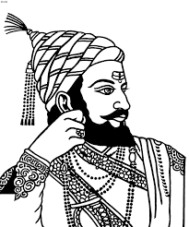RED | 1 MRS.VIDHYA CHAUDHARI. | 1 MRS. NITA PARMAR
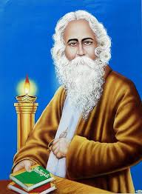YELLOW | 1 MRS.GEETA MAKWANA | 1 MRS VANDANA SONARE
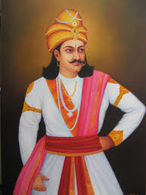GREEN | 1 MR. YOGESH SUTHARIYA | 1 MRS NILAM PATEL  2 PRT 1
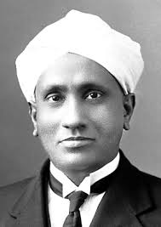BLUE | 1MRS MADHURA TAKKAR | 1 MR. MAHENDRA MEENA
SESSION 2019-20
LIST OF HOUSE MASTERS

CCA I/C HM

